**Use Case Title:** Handwritten Digit Recognition Web App

**Student Name:** S.Sana Fathima  
**Register Number:** 11122213033  
**Institution:** Krishnasamy college of science, arts and management for women  
**Department:** BCA   
**Date of Submission:** 13.03.2025

### 1. Problem Statement

Handwritten digit recognition plays a critical role in various AI-powered applications, including **automated form processing, banking systems, postal services, and digitization of handwritten documents**. Traditional data entry methods are **time-consuming, error-prone, and labor-intensive**, leading to inefficiencies in industries that rely heavily on numeric data.

#### Real- World Challenges:

* **Banking & Finance:** Manual processing of handwritten checks and financial documents results in **transaction delays and fraud risks**. Automated digit recognition can enable **faster verification, fraud detection, and digitized banking records**.
* **Education & E-Learning:** Schools and universities still rely on handwritten assignments, exams, and notes. AI-powered digit recognition can facilitate **automatic grading, digital archiving, and assist students with disabilities** by converting handwritten text into readable digital formats.
* **Healthcare & Medical Records:** Many hospitals continue to store patient prescriptions and records in handwritten format, increasing the chance of errors. Digitization via AI-powered recognition can **improve patient safety, streamline record retrieval, and assist in medical insurance claims**.
* **Government & Legal Documentation:** Legal systems and government offices process a vast number of handwritten forms for identity verification, tax filings, and regulatory compliance. AI-powered digit recognition ensures **faster data processing, improved accuracy, and reduced human workload**.
* **Postal & Logistics Services:** Package tracking, address verification, and sorting of handwritten postal codes require efficient automation. AI-based digit recognition can **speed up mail processing, reduce sorting errors, and optimize logistics**.
* **Retail & Point of Sale (POS) Systems:** Many small businesses still rely on handwritten sales records. Digit recognition can **automate inventory management, sales tracking, and streamline financial reporting**.
* **Accessibility & Inclusivity:** Individuals with disabilities or learning challenges often struggle with handwritten content. AI-driven digit recognition can **enhance accessibility by converting handwritten materials into speech or digital text formats**.

To address these challenges, i propose a **Handwritten Digit Recognition Web App** that allows users to draw a digit (0-9) on a digital canvas. An **AI model, trained using deep learning techniques, will recognize and classify the digit in real-time**, ensuring high accuracy and efficiency. This web-based solution will be accessible, lightweight, and optimized for multiple devices.

### 2. Proposed Solution

Our solution is an interactive web application where users can draw a digit using a mouse or touchscreen. The system leverages a **Convolutional Neural Network (CNN) trained on the MNIST dataset** to accurately predict handwritten digits. The application provides **instant feedback** and is designed to run directly in a web browser without requiring additional software installations.

#### Key Features:

* **Interactive Drawing Canvas:** Users can freely draw digits using their mouse or touchscreen.
* **AI-Based Recognition:** A **lightweight, optimized CNN model** for real-time digit classification.
* **Instant Prediction & Confidence Score:** The app displays the predicted digit along with a confidence percentage.
* **Error Handling & Clear Option:** Users can clear the canvas and retry if needed.
* **Cloud-Based Deployment:** Hosted on **GitHub Pages, Netlify, or Hugging Face Spaces** for free accessibility.
* **Cross-Platform Compatibility:** Fully responsive for desktop, tablet, and mobile devices.
* **User Data Privacy:** The system runs entirely in the browser, ensuring user data is not sent to external servers.

### 3. Technologies & Tools Considered

* **Programming Languages:** Python (for model training), JavaScript (for frontend development).
* **Frameworks & Libraries:** TensorFlow/Keras, TensorFlow.js, HTML, CSS, JavaScript, React.js.
* **Dataset:** MNIST (Handwritten Digits Dataset) for training and validation.
* **Deployment Platforms:** GitHub Pages, Netlify, Hugging Face Spaces for hosting.

### 4. Solution Architecture & Workflow

1. **Model Training:** A **CNN-based model** is trained using TensorFlow/Keras on the MNIST dataset.
2. **Model Optimization & Conversion:** The trained model is converted into **TensorFlow.js** format for web compatibility.
3. **Frontend Development:** A responsive web application is developed using **React.js (or Vanilla JavaScript)** with a drawing canvas.
4. **AI Model Integration:** The **TensorFlow.js model** is embedded in the web app for real-time digit recognition.
5. **Deployment & Testing:** The application is deployed on free hosting platforms and tested across multiple device.

#### Flowchart Representation:

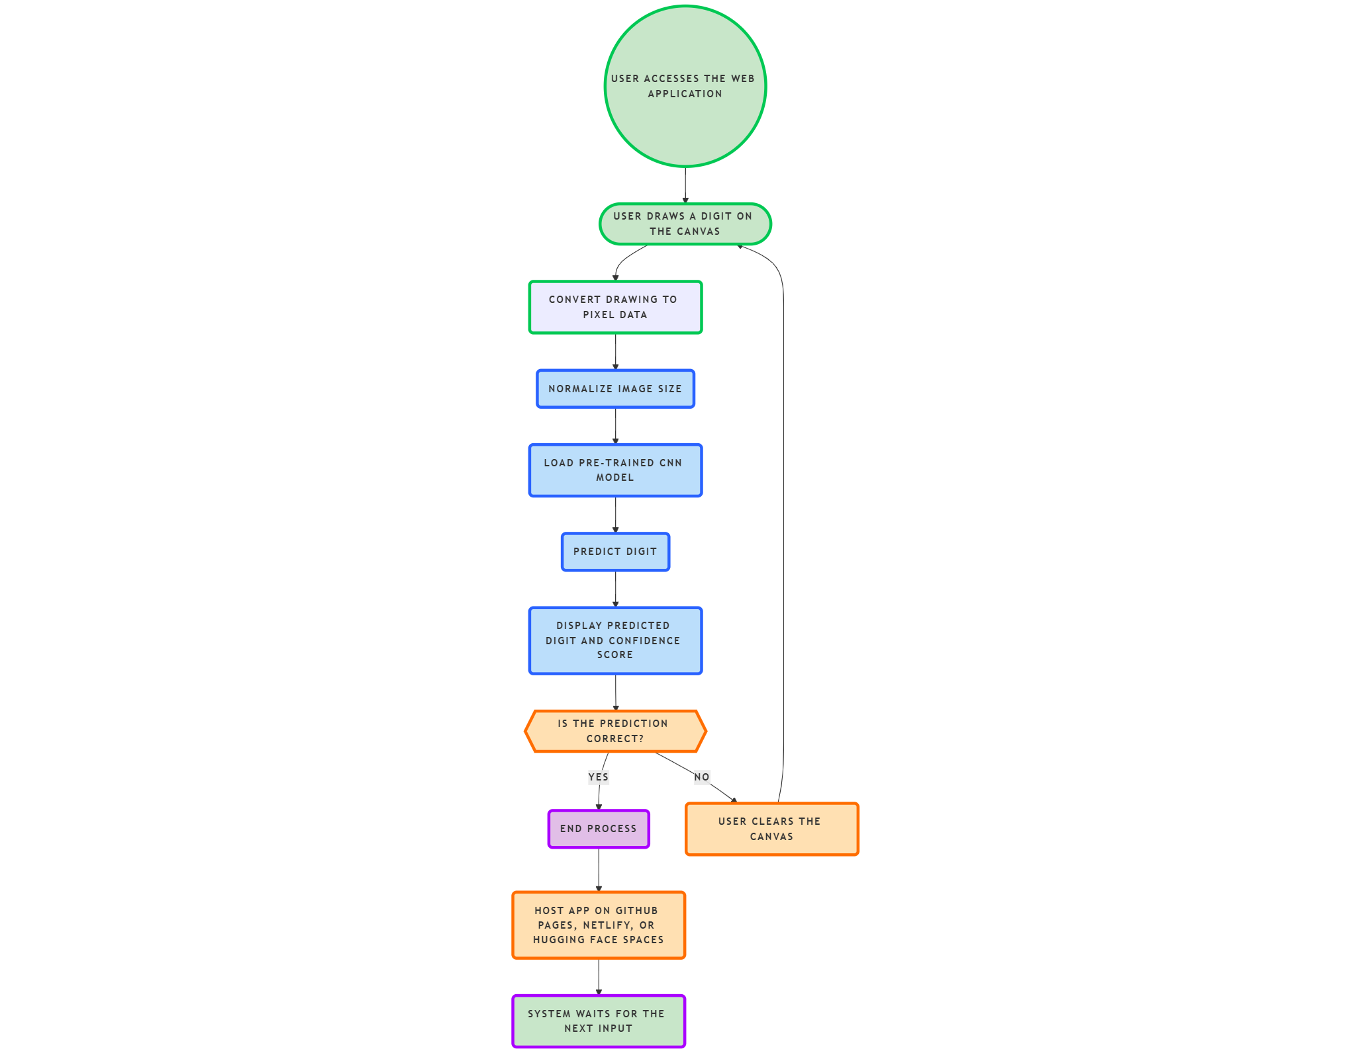

### 5. Feasibility & Challenges

#### Feasibility:

* **Browser-Based Execution:** The TensorFlow.js model runs entirely in the browser, eliminating the need for a backend server.
* **Scalability & Cost Efficiency:** The system is **low-cost and highly scalable**, making it accessible to a wide range of users.
* **AI Model Optimization:** Model compression techniques ensure fast inference without compromising accuracy.

#### Challenges & Solutions:

* **Accuracy Variability:** To improve model accuracy, we implement **data augmentation, dropout layers, and additional training epochs**.
* **Latency Reduction:** The model is **optimized using pruning and quantization** to improve speed and performance.
* **User Experience & Accessibility:** A well-structured UI and error-handling mechanisms are included for an intuitive experience.
* **Edge Cases Handling:** To recognize diverse handwriting styles, additional training with **real-world datasets** will be explored.
* **Security & Data Privacy:** Since the system runs in-browser, no user data is stored or transmitted, ensuring privacy and compliance with data protection laws.

### 6. Expected Outcome & Impact

* **A fully deployed web application** where users can draw digits, and the model predicts them with high accuracy.
* **Enhanced automation** in fields like banking (check scanning), education (math learning apps), and digitization of handwritten forms.
* **Reduced dependency on manual data entry**, improving speed and minimizing errors in digital form processing.
* **Improved accessibility** for individuals with disabilities who need digitized content for learning and communication.
* **A public GitHub repository** with the source code, trained model, and detailed setup instructions for further development.

### 7. Future Enhancements

* **Support for Multi-Digit Recognition:** Extending the model to recognize multiple digits instead of single characters.
* **Offline Functionality:** Implementing **Progressive Web App (PWA) features** for offline use.
* **Voice-Based Digit Recognition:** Expanding functionality to recognize spoken digits for accessibility.
* **Mobile Application Development:** Building an **Android/iOS app** for on-the-go digit recognition.
* **Custom Dataset Training:** Enhancing accuracy by training the model on **real-world handwritten digits** beyond MNIST.
* **Support for Mathematical Expressions:** Expanding the model to recognize handwritten mathematical equations for education and research applications.
* **Integration with IoT Devices:** Enabling the system to work with smart pens, tablets, and digital whiteboards for advanced use cases.